**US Accidents Visualizations**

This document contains the updated visualization solutions along with other visualizations as suggested by our mentor, Mr. Apurba. You can find the updated visualization versions (Visualization 4,5, 6,7, 13), with their heading highlighted as yellow

**QUERY 1:**

with cte1 as

(select state , severity, count(severity) as severity_1 from us_accidents_dec_19_database.us_accident_v3 where severity = 1 group by severity, state),

cte2 as

(select state , severity, count(severity) as severity_2 from us_accidents_dec_19_database.us_accident_v3 where severity = 2 group by severity, state),

cte3 as

(select state, severity, count(severity) as severity_3 from us_accidents_dec_19_database.us_accident_v3 where severity = 3 group by severity, state),

cte4 as

(select state, severity, count(severity) as severity_4 from us_accidents_dec_19_database.us_accident_v3 where severity = 4 group by severity, state)

select a.state, severity_1, severity_2, severity_3, severity_4, sum(severity_1 + severity_2 + severity_3 + severity_4) as tot_accidents from cte1 a

join cte2 b

on a.state = b.state

join cte3 c

on a.state = c.state

join cte4 d

on a.state = d.state

group by a.state, severity_1, severity_2, severity_3, severity_4

order by tot_accidents desc

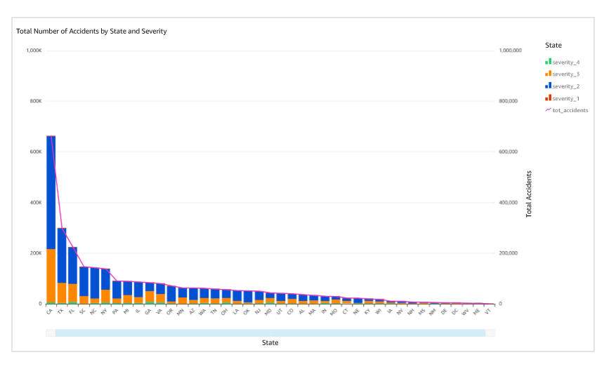

**QUERY 3:**

with cte1 as

(select date_diff('minute', start_time, end_time) as duration from awsdatacatalog.us_accidents_dec_19_database.us_accident_v3),

cte2 as

(select

case

when duration <= 59 then 'minutes'

when duration between 60 and 239 then 'hours'

when duration between 240 and 959 then '4hours_16hours'

when duration between 960 and 1439 then '16hours_24hours'

when duration >=1440 then 'days'

end as duration_section

from cte1)

select duration_section, count(duration_section) as count from cte2

group by duration_section

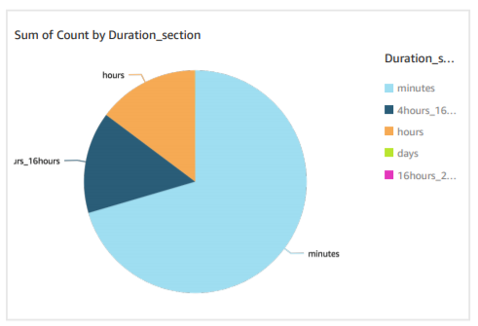

**QUERY 4: (updated)**

with cte1 as(

select weather_condition, severity, count(*) as weather_accidents from us_accidents_dec_19_database.us_accident_v2

where weather_condition <> ''

group by weather_condition, severity

order by weather_condition)

select a.weather_condition, severity, weather_accidents, total_accidents, cast(weather_accidents as double)*100/total_accidents as perc_severity_accidents from cte1 a

inner join (select weather_condition, count(*) as total_accidents from us_accidents_dec_19_database.us_accident_v3

group by weather_condition) b

on a.weather_condition = b.weather_condition

**QUERY 5: (updated)**

**TEMPERATURE:**

with cte1 as

(select date_format(start_time, '%Y%v') AS date,severity,weather_condition,

case

when weather_condition = 'Clear' then 'good'

when weather_condition like 'Cloudy%' then 'good'

when weather_condition = 'Drizzle' then 'good'

when weather_condition = 'Drizzle / Windy' then 'good'

when weather_condition like 'Fair%' then 'good'

when weather_condition = 'Haze' then 'good'

when weather_condition like 'Light%' then 'good'

when weather_condition = 'Mist' then 'good'

when weather_condition like 'Mostly%' then 'good'

when weather_condition = 'N/A Precipitation' then 'good'

when weather_condition = 'Overcast' then 'good'

when weather_condition like 'Partial%' then 'good'

when weather_condition like 'Partly%' then 'good'

when weather_condition = 'Patches of Fog' then 'good'

when weather_condition = 'Scattered Clouds' then 'good'

when weather_condition = 'Shallow Fog' then 'good'

when weather_condition = 'Showers in the Vicinity' then 'good'

when weather_condition = 'Small Hail' then 'good'

when weather_condition = 'Thunder in the Vicinity' then 'good'

else 'bad' end as weather_type,

case

when temperature between -10 and 1 then '0'

when temperature between 2 and 13 then '1'

when temperature between 14 and 25 then '2'

when temperature between 26 and 37 then '3'

when temperature between 38 and 49 then '4'

when temperature between 50 and 61 then '5'

when temperature between 62 and 73 then '6'

when temperature between 74 and 85 then '7'

when temperature between 86 and 97 then '8'

when temperature between 98 and 109 then '9'

else 'out_of_index' end as temp_index

from AwsDataCatalog.us_accidents_dec_19_database.us_accident_v3),

cte2 as

(select * from cte1 where temp_index <> 'out_of_index'),

cte3 as

(select *,

case

when severity = 1 and weather_type = 'good' then 'sev1_good'

when severity = 2 and weather_type = 'good' then 'sev2_good'

when severity = 3 and weather_type = 'good' then 'sev3_good'

when severity = 4 and weather_type = 'good' then 'sev4_good'

when severity = 1 and weather_type = 'bad' then 'sev1_bad'

when severity = 2 and weather_type = 'bad' then 'sev2_bad'

when severity = 3 and weather_type = 'bad' then 'sev3_bad'

when severity = 4 and weather_type = 'bad' then 'sev4_bad'

else 'unknown_weather' end as good_bad_sev

from cte2),

cte4 as

(select date, temp_index,good_bad_sev,count(*) as number_of_accident from cte3 group by date, temp_index,good_bad_sev

order by date, temp_index,good_bad_sev asc)

select ((cast(date as bigint)*10)+cast(temp_index as bigint)) as year_week_temp_index, kv1['sev1_good'] as Sev_1_good_weather,

kv2['sev2_good'] as Sev_2_good_weather,

kv3['sev3_good'] as Sev_3_good_weather,

kv4['sev4_good'] as Sev_4_good_weather,

kv5['sev1_bad'] as Sev_1_bad_weather,

kv6['sev2_bad'] as Sev_2_bad_weather,

kv7['sev3_bad'] as Sev_3_bad_weather,

kv8['sev4_bad'] as Sev_4_bad_weather

from (

select date, temp_index, map_agg(good_bad_sev, number_of_accident) kv1,

map_agg(good_bad_sev, number_of_accident) kv2,

map_agg(good_bad_sev, number_of_accident) kv3,

map_agg(good_bad_sev, number_of_accident) kv4,

map_agg(good_bad_sev, number_of_accident) kv5,

map_agg(good_bad_sev, number_of_accident) kv6,

map_agg(good_bad_sev, number_of_accident) kv7,

map_agg(good_bad_sev, number_of_accident) kv8

from cte4

group by date, temp_index)

order by year_week_temp_index

**Good Weather Analysis:**

**Bad Weather Analysis:**

**VISIBILITY:**

with cte1 as

(select date_format(start_time, '%Y%v') AS date,severity,weather_condition,

case

when weather_condition = 'Clear' then 'good'

when weather_condition like 'Cloudy%' then 'good'

when weather_condition = 'Drizzle' then 'good'

when weather_condition = 'Drizzle / Windy' then 'good'

when weather_condition like 'Fair%' then 'good'

when weather_condition = 'Haze' then 'good'

when weather_condition like 'Light%' then 'good'

when weather_condition = 'Mist' then 'good'

when weather_condition like 'Mostly%' then 'good'

when weather_condition = 'N/A Precipitation' then 'good'

when weather_condition = 'Overcast' then 'good'

when weather_condition like 'Partial%' then 'good'

when weather_condition like 'Partly%' then 'good'

when weather_condition = 'Patches of Fog' then 'good'

when weather_condition = 'Scattered Clouds' then 'good'

when weather_condition = 'Shallow Fog' then 'good'

when weather_condition = 'Showers in the Vicinity' then 'good'

when weather_condition = 'Small Hail' then 'good'

when weather_condition = 'Thunder in the Vicinity' then 'good'

else 'bad' end as weather_type,

case

when visibility between 0 and 0.19 then '1'

when visibility between 0.20 and 0.39 then '2'

when visibility between 0.40 and 0.59 then '3'

when visibility between 0.60 and 0.79 then '4'

when visibility between 0.80 and 0.99 then '5'

when visibility between 1.00 and 1.19 then '6'

when visibility between 1.20 and 1.39 then '7'

when visibility between 1.40 and 1.59 then '8'

when visibility between 1.60 and 1.79 then '9'

when visibility between 1.80 and 2.00 then '10'

else 'visibility unknown'

end as visibility_range

from us_accidents_dec_19_database.us_accident_v3),

cte2 as

(select *,

case

when severity = 1 and weather_type = 'good' then 'sev1_good'

when severity = 2 and weather_type = 'good' then 'sev2_good'

when severity = 3 and weather_type = 'good' then 'sev3_good'

when severity = 4 and weather_type = 'good' then 'sev4_good'

when severity = 1 and weather_type = 'bad' then 'sev1_bad'

when severity = 2 and weather_type = 'bad' then 'sev2_bad'

when severity = 3 and weather_type = 'bad' then 'sev3_bad'

when severity = 4 and weather_type = 'bad' then 'sev4_bad'

else 'unknown_weather' end as good_bad_sev

from cte1

where visibility_range <> 'visibility unknown'),

cte3 as

(select date,visibility_range,good_bad_sev,count(*) as number_of_accident from cte2 group by date,visibility_range,good_bad_sev

order by date,visibility_range,good_bad_sev asc)

select ((cast(date as bigint)*100)+cast(visibility_range as bigint)) as year_week_visi_index,

kv1['sev1_good'] as Sev_1_good_weather,

kv2['sev2_good'] as Sev_2_good_weather,

kv3['sev3_good'] as Sev_3_good_weather,

kv4['sev4_good'] as Sev_4_good_weather,

kv5['sev1_bad'] as Sev_1_bad_weather,

kv6['sev2_bad'] as Sev_2_bad_weather,

kv7['sev3_bad'] as Sev_3_bad_weather,

kv8['sev4_bad'] as Sev_4_bad_weather

from (

select date,visibility_range, map_agg(good_bad_sev, number_of_accident) kv1,

map_agg(good_bad_sev, number_of_accident) kv2,

map_agg(good_bad_sev, number_of_accident) kv3,

map_agg(good_bad_sev, number_of_accident) kv4,

map_agg(good_bad_sev, number_of_accident) kv5,

map_agg(good_bad_sev, number_of_accident) kv6,

map_agg(good_bad_sev, number_of_accident) kv7,

map_agg(good_bad_sev, number_of_accident) kv8

from cte3

group by date,visibility_range)

order by year_week_visi_index

**Good Weather Analysis:**

**Bad Weather Analysis:**

**WIND SPEED:**

with cte1 as

(select date_format(start_time, '%Y%v') AS date,severity,weather_condition,wind_speed,

case

when weather_condition = 'Clear' then 'good'

when weather_condition like 'Cloudy%' then 'good'

when weather_condition = 'Drizzle' then 'good'

when weather_condition = 'Drizzle / Windy' then 'good'

when weather_condition like 'Fair%' then 'good'

when weather_condition = 'Haze' then 'good'

when weather_condition like 'Light%' then 'good'

when weather_condition = 'Mist' then 'good'

when weather_condition like 'Mostly%' then 'good'

when weather_condition = 'N/A Precipitation' then 'good'

when weather_condition = 'Overcast' then 'good'

when weather_condition like 'Partial%' then 'good'

when weather_condition like 'Partly%' then 'good'

when weather_condition = 'Patches of Fog' then 'good'

when weather_condition = 'Scattered Clouds' then 'good'

when weather_condition = 'Shallow Fog' then 'good'

when weather_condition = 'Showers in the Vicinity' then 'good'

when weather_condition = 'Small Hail' then 'good'

when weather_condition = 'Thunder in the Vicinity' then 'good'

else 'bad' end as weather_type,

case

when wind_speed between 0 and 9 then '0'

when wind_speed between 10 and 19 then '1'

when wind_speed between 20 and 29 then '2'

when wind_speed between 30 and 39 then '3'

when wind_speed between 40 and 49 then '4'

when wind_speed between 50 and 59 then '5'

when wind_speed between 60 and 69 then '6'

when wind_speed between 70 and 79 then '7'

when wind_speed between 80 and 89 then '8'

when wind_speed between 90 and 99 then '9'

else 'out_of_index' end as wind_speed_index

from AwsDataCatalog.us_accidents_dec_19_database.us_accident_v3),

cte2 as

(select * from cte1 where wind_speed_index <> 'out_of_index'),

cte3 as

(select *,

case

when severity = 1 and weather_type = 'good' then 'sev1_good'

when severity = 2 and weather_type = 'good' then 'sev2_good'

when severity = 3 and weather_type = 'good' then 'sev3_good'

when severity = 4 and weather_type = 'good' then 'sev4_good'

when severity = 1 and weather_type = 'bad' then 'sev1_bad'

when severity = 2 and weather_type = 'bad' then 'sev2_bad'

when severity = 3 and weather_type = 'bad' then 'sev3_bad'

when severity = 4 and weather_type = 'bad' then 'sev4_bad'

else 'unknown_weather' end as good_bad_sev

from cte2),

cte4 as

(select date, wind_speed_index, good_bad_sev,count(*) as number_of_accident from cte3 group by date, wind_speed_index,good_bad_sev

order by date, wind_speed_index,good_bad_sev asc)

select ((cast(date as bigint)*10)+cast(wind_speed_index as bigint)) as year_week_wind_speed_index, kv1['sev1_good'] as Sev_1_good_weather,

kv2['sev2_good'] as Sev_2_good_weather,

kv3['sev3_good'] as Sev_3_good_weather,

kv4['sev4_good'] as Sev_4_good_weather,

kv5['sev1_bad'] as Sev_1_bad_weather,

kv6['sev2_bad'] as Sev_2_bad_weather,

kv7['sev3_bad'] as Sev_3_bad_weather,

kv8['sev4_bad'] as Sev_4_bad_weather

from (

select date, wind_speed_index, map_agg(good_bad_sev, number_of_accident) kv1,

map_agg(good_bad_sev, number_of_accident) kv2,

map_agg(good_bad_sev, number_of_accident) kv3,

map_agg(good_bad_sev, number_of_accident) kv4,

map_agg(good_bad_sev, number_of_accident) kv5,

map_agg(good_bad_sev, number_of_accident) kv6,

map_agg(good_bad_sev, number_of_accident) kv7,

map_agg(good_bad_sev, number_of_accident) kv8

from cte4

group by date, wind_speed_index)

order by year_week_wind_speed_index

**Good Weather Analysis:**

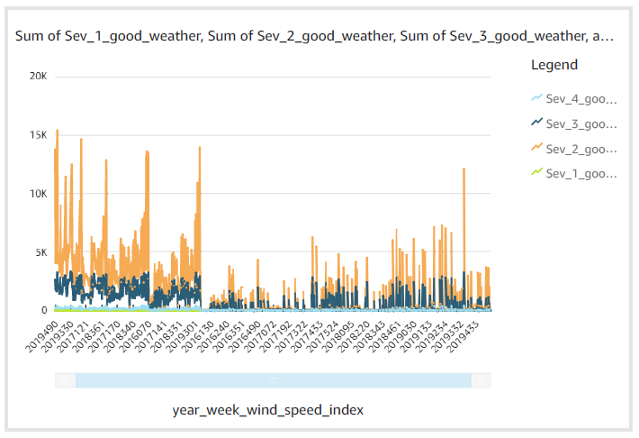

**Bad Weather Analysis:**

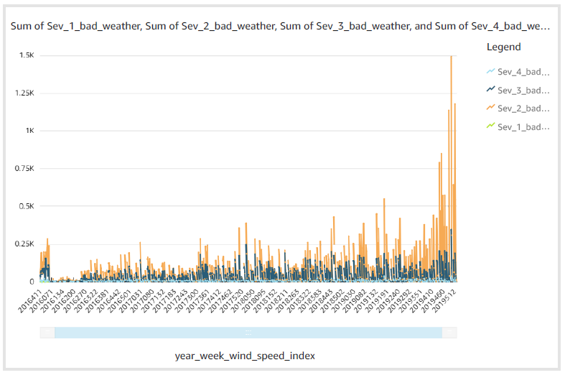

**TRAFFIC SIGNAL:**

with cte1 as

(select date_format(start_time, '%Y%v') AS date,severity,weather_condition, traffic_signal,

case

when weather_condition = 'Clear' then 'good'

when weather_condition like 'Cloudy%' then 'good'

when weather_condition = 'Drizzle' then 'good'

when weather_condition = 'Drizzle / Windy' then 'good'

when weather_condition like 'Fair%' then 'good'

when weather_condition = 'Haze' then 'good'

when weather_condition like 'Light%' then 'good'

when weather_condition = 'Mist' then 'good'

when weather_condition like 'Mostly%' then 'good'

when weather_condition = 'N/A Precipitation' then 'good'

when weather_condition = 'Overcast' then 'good'

when weather_condition like 'Partial%' then 'good'

when weather_condition like 'Partly%' then 'good'

when weather_condition = 'Patches of Fog' then 'good'

when weather_condition = 'Scattered Clouds' then 'good'

when weather_condition = 'Shallow Fog' then 'good'

when weather_condition = 'Showers in the Vicinity' then 'good'

when weather_condition = 'Small Hail' then 'good'

when weather_condition = 'Thunder in the Vicinity' then 'good'

else 'bad' end as weather_type,

case

when traffic_signal = false then 0

when traffic_signal = true then 1

end as traffic_signal_index

from AwsDataCatalog.us_accidents_dec_19_database.us_accident_v3),

cte2 as

(select *,

case

when severity = 1 and weather_type = 'good' then 'sev1_good'

when severity = 2 and weather_type = 'good' then 'sev2_good'

when severity = 3 and weather_type = 'good' then 'sev3_good'

when severity = 4 and weather_type = 'good' then 'sev4_good'

when severity = 1 and weather_type = 'bad' then 'sev1_bad'

when severity = 2 and weather_type = 'bad' then 'sev2_bad'

when severity = 3 and weather_type = 'bad' then 'sev3_bad'

when severity = 4 and weather_type = 'bad' then 'sev4_bad'

else 'unknown_weather' end as good_bad_sev

from cte1),

cte3 as

(select date, traffic_signal_index,good_bad_sev,count(*) as number_of_accident from cte2 group by date, traffic_signal_index,good_bad_sev

order by date, traffic_signal_index,good_bad_sev asc)

select ((cast(date as bigint)*10)+cast(traffic_signal_index as bigint)) as year_week_traffic_signal_index, kv1['sev1_good'] as Sev_1_good_weather,

kv2['sev2_good'] as Sev_2_good_weather,

kv3['sev3_good'] as Sev_3_good_weather,

kv4['sev4_good'] as Sev_4_good_weather,

kv5['sev1_bad'] as Sev_1_bad_weather,

kv6['sev2_bad'] as Sev_2_bad_weather,

kv7['sev3_bad'] as Sev_3_bad_weather,

kv8['sev4_bad'] as Sev_4_bad_weather

from (

select date, traffic_signal_index, map_agg(good_bad_sev, number_of_accident) kv1,

map_agg(good_bad_sev, number_of_accident) kv2,

map_agg(good_bad_sev, number_of_accident) kv3,

map_agg(good_bad_sev, number_of_accident) kv4,

map_agg(good_bad_sev, number_of_accident) kv5,

map_agg(good_bad_sev, number_of_accident) kv6,

map_agg(good_bad_sev, number_of_accident) kv7,

map_agg(good_bad_sev, number_of_accident) kv8

from cte3

group by date, traffic_signal_index)

order by year_week_traffic_signal_index

**Good Weather Analysis:**

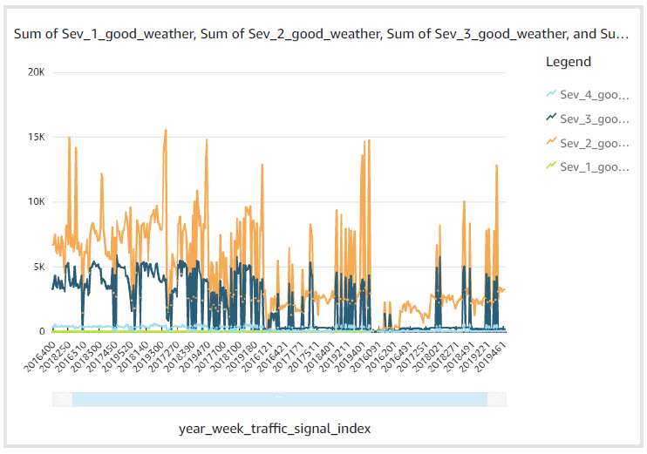

**Bad Weather Analysis:**

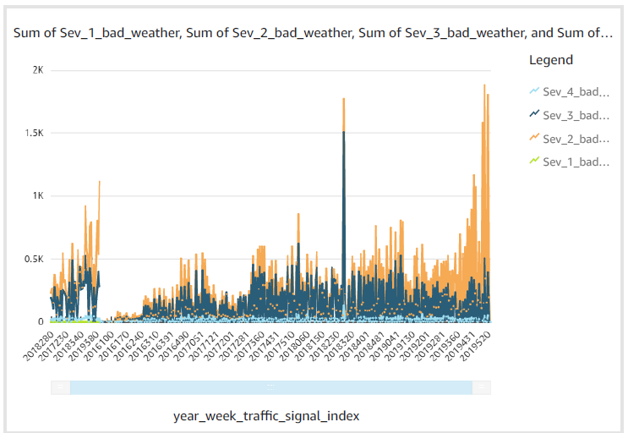

**CROSSING:**

with cte1 as

(select date_format(start_time, '%Y%v') AS date,severity,weather_condition, crossing,

case

when weather_condition = 'Clear' then 'good'

when weather_condition like 'Cloudy%' then 'good'

when weather_condition = 'Drizzle' then 'good'

when weather_condition = 'Drizzle / Windy' then 'good'

when weather_condition like 'Fair%' then 'good'

when weather_condition = 'Haze' then 'good'

when weather_condition like 'Light%' then 'good'

when weather_condition = 'Mist' then 'good'

when weather_condition like 'Mostly%' then 'good'

when weather_condition = 'N/A Precipitation' then 'good'

when weather_condition = 'Overcast' then 'good'

when weather_condition like 'Partial%' then 'good'

when weather_condition like 'Partly%' then 'good'

when weather_condition = 'Patches of Fog' then 'good'

when weather_condition = 'Scattered Clouds' then 'good'

when weather_condition = 'Shallow Fog' then 'good'

when weather_condition = 'Showers in the Vicinity' then 'good'

when weather_condition = 'Small Hail' then 'good'

when weather_condition = 'Thunder in the Vicinity' then 'good'

else 'bad' end as weather_type,

case

when crossing = false then 0

when crossing = true then 1

end as crossing_index

from AwsDataCatalog.us_accidents_dec_19_database.us_accident_v3),

cte2 as

(select *,

case

when severity = 1 and weather_type = 'good' then 'sev1_good'

when severity = 2 and weather_type = 'good' then 'sev2_good'

when severity = 3 and weather_type = 'good' then 'sev3_good'

when severity = 4 and weather_type = 'good' then 'sev4_good'

when severity = 1 and weather_type = 'bad' then 'sev1_bad'

when severity = 2 and weather_type = 'bad' then 'sev2_bad'

when severity = 3 and weather_type = 'bad' then 'sev3_bad'

when severity = 4 and weather_type = 'bad' then 'sev4_bad'

else 'unknown_weather' end as good_bad_sev

from cte1),

cte3 as

(select date, crossing_index,good_bad_sev,count(*) as number_of_accident from cte2 group by date, crossing_index,good_bad_sev

order by date, crossing_index,good_bad_sev asc)

select ((cast(date as bigint)*10)+cast(crossing_index as bigint)) as year_week_crossing_index, kv1['sev1_good'] as Sev_1_good_weather,

kv2['sev2_good'] as Sev_2_good_weather,

kv3['sev3_good'] as Sev_3_good_weather,

kv4['sev4_good'] as Sev_4_good_weather,

kv5['sev1_bad'] as Sev_1_bad_weather,

kv6['sev2_bad'] as Sev_2_bad_weather,

kv7['sev3_bad'] as Sev_3_bad_weather,

kv8['sev4_bad'] as Sev_4_bad_weather

from (

select date, crossing_index, map_agg(good_bad_sev, number_of_accident) kv1,

map_agg(good_bad_sev, number_of_accident) kv2,

map_agg(good_bad_sev, number_of_accident) kv3,

map_agg(good_bad_sev, number_of_accident) kv4,

map_agg(good_bad_sev, number_of_accident) kv5,

map_agg(good_bad_sev, number_of_accident) kv6,

map_agg(good_bad_sev, number_of_accident) kv7,

map_agg(good_bad_sev, number_of_accident) kv8

from cte3

group by date, crossing_index)

order by year_week_crossing_index

**Good Weather Analysis:**

**Bad Weather Analysis:**

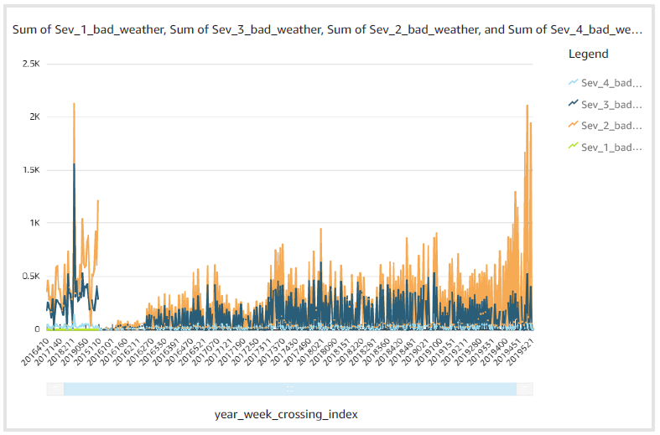

**JUNCTION:**

with cte1 as

(select date_format(start_time, '%Y%v') AS date,severity,weather_condition, crossing,

case

when weather_condition = 'Clear' then 'good'

when weather_condition like 'Cloudy%' then 'good'

when weather_condition = 'Drizzle' then 'good'

when weather_condition = 'Drizzle / Windy' then 'good'

when weather_condition like 'Fair%' then 'good'

when weather_condition = 'Haze' then 'good'

when weather_condition like 'Light%' then 'good'

when weather_condition = 'Mist' then 'good'

when weather_condition like 'Mostly%' then 'good'

when weather_condition = 'N/A Precipitation' then 'good'

when weather_condition = 'Overcast' then 'good'

when weather_condition like 'Partial%' then 'good'

when weather_condition like 'Partly%' then 'good'

when weather_condition = 'Patches of Fog' then 'good'

when weather_condition = 'Scattered Clouds' then 'good'

when weather_condition = 'Shallow Fog' then 'good'

when weather_condition = 'Showers in the Vicinity' then 'good'

when weather_condition = 'Small Hail' then 'good'

when weather_condition = 'Thunder in the Vicinity' then 'good'

else 'bad' end as weather_type,

case

when junction = false then 0

when junction = true then 1

end as junction_index

from AwsDataCatalog.us_accidents_dec_19_database.us_accident_v3),

cte2 as

(select *,

case

when severity = 1 and weather_type = 'good' then 'sev1_good'

when severity = 2 and weather_type = 'good' then 'sev2_good'

when severity = 3 and weather_type = 'good' then 'sev3_good'

when severity = 4 and weather_type = 'good' then 'sev4_good'

when severity = 1 and weather_type = 'bad' then 'sev1_bad'

when severity = 2 and weather_type = 'bad' then 'sev2_bad'

when severity = 3 and weather_type = 'bad' then 'sev3_bad'

when severity = 4 and weather_type = 'bad' then 'sev4_bad'

else 'unknown_weather' end as good_bad_sev

from cte1),

cte3 as

(select date, junction_index,good_bad_sev,count(*) as number_of_accident from cte2 group by date, junction_index,good_bad_sev

order by date, junction_index,good_bad_sev asc)

select ((cast(date as bigint)*10)+ cast(junction_index as bigint)) as year_week_junction_index, kv1['sev1_good'] as Sev_1_good_weather,

kv2['sev2_good'] as Sev_2_good_weather,

kv3['sev3_good'] as Sev_3_good_weather,

kv4['sev4_good'] as Sev_4_good_weather,

kv5['sev1_bad'] as Sev_1_bad_weather,

kv6['sev2_bad'] as Sev_2_bad_weather,

kv7['sev3_bad'] as Sev_3_bad_weather,

kv8['sev4_bad'] as Sev_4_bad_weather

from (

select date, junction_index, map_agg(good_bad_sev, number_of_accident) kv1,

map_agg(good_bad_sev, number_of_accident) kv2,

map_agg(good_bad_sev, number_of_accident) kv3,

map_agg(good_bad_sev, number_of_accident) kv4,

map_agg(good_bad_sev, number_of_accident) kv5,

map_agg(good_bad_sev, number_of_accident) kv6,

map_agg(good_bad_sev, number_of_accident) kv7,

map_agg(good_bad_sev, number_of_accident) kv8

from cte3

group by date, junction_index)

order by year_week_junction_index

**Good Weather Analysis:**

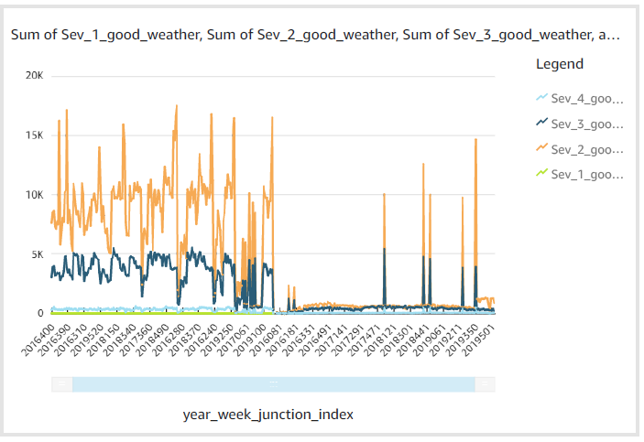

**Bad Weather Analysis:**

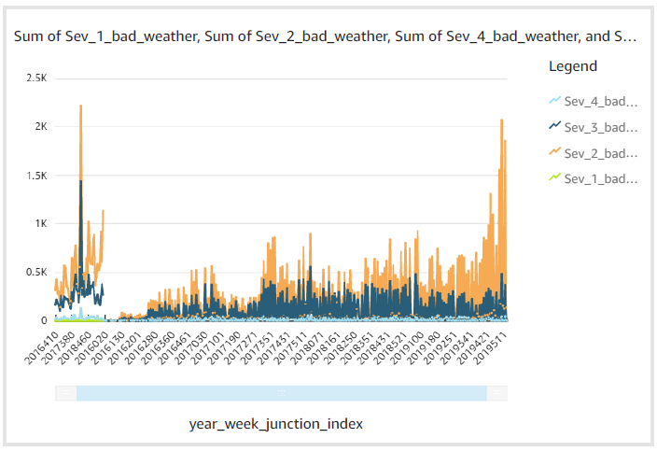

**QUERY 6: (updated)**

select date_format(start_time, '%Y, %v') as Year_week , severity, count(*) as Total_accidents from us_accidents_dec_19_database.us_accident_v3 group by start_time, severity

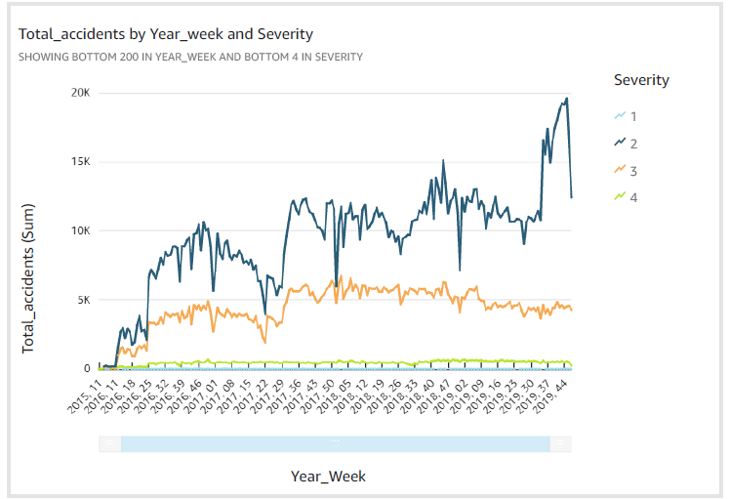

**QUERY 7: (updated)**

select severity, avg(distance) as avg_distance, max(distance) as max_distance, round(stddev(distance),2) as std_dev from us_accidents_dec_19_database.us_accident_v3 group by severity order by severity asc

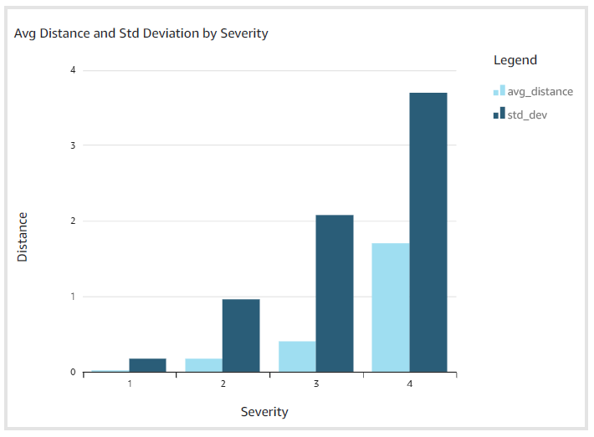

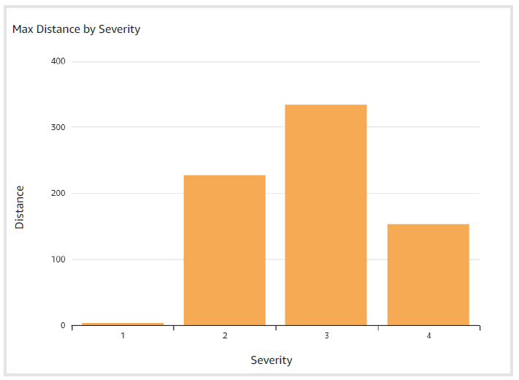

**QUERY 10:**

with cte1 as

(SELECT row, slno,pattrn, concpt, n_description,

regexp_extract_all(lower(a.n_description), (b.pattrn)) AS regexp_group1,

cardinality(regexp_extract_all(lower(a.n_description),

b.pattrn)) car

FROM AwsDataCatalog.us_accidents_dec_19_database.base_corpus3 a

CROSS JOIN AwsDataCatalog.us_accidents_dec_19_database.concept7 b

order by slno)

select distinct(concpt),

case

when slno >=20 and slno <25 then 20

when slno >=25 and slno <30 then 25

when slno >=30 and slno <35 then 30

when slno >=35 and slno <40 then 35

when slno >=40 and slno <45 then 40

when slno >=45 and slno <50 then 45

when slno >=50 and slno <55 then 50

when slno >=55 and slno <60 then 55

when slno >=60 and slno <65 then 60

when slno >=65 and slno <70 then 65

when slno >=70 and slno <75 then 70

when slno >=75 and slno <80 then 75

when slno >=80 and slno <85 then 80

when slno >=85 and slno <90 then 85

when slno >=90 and slno <95 then 90

when slno >=95 and slno <100 then 95

when slno >=100 and slno <105 then 100

when slno >=105 and slno <110 then 105

when slno >=110 and slno <115 then 110

when slno >=115 and slno <120 then 115

when slno >=120 and slno <125 then 120

when slno >=125 and slno <130 then 125

when slno >=130 and slno <135 then 130

when slno >=135 and slno <140 then 135

when slno >=140 and slno <145 then 140

when slno >=145 and slno <150 then 145

when slno >=150 and slno <155 then 150

when slno >=155 and slno <160 then 155

when slno >=160 and slno <300 then 160

when slno = 300 then 300

end as slno,

sum(car) over (partition by concpt) as freq

from cte1 where car>0

order by slno

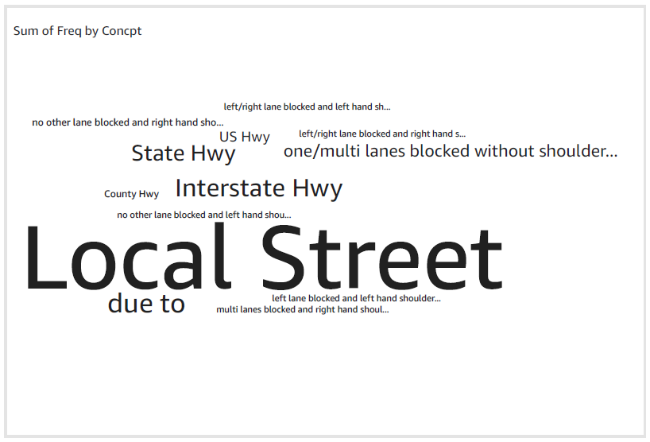

**QUERY 13: (updated)**

select state, start_date, avg_prec,

sum(avg_prec) over (partition by state order by start_date,avg_prec) as run_total

from

(select state, date_format(start_time, '%Y%m') AS start_date, avg(tot_prec) AS avg_prec

from (

select state,zipcode, start_time, date_diff('second', start_time, end_time) AS dur, "precipitation" AS prec,sum("precipitation") OVER (partition by state,

date_format(start_time, '%Y-%m-%d'),zipcode order by start_time) AS tot_prec,rank() OVER (partition by state,

date_format(start_time, '%Y-%m-%d'),zipcode order by start_time desc ) AS rnk

from us_accident_v3 where

--state='CA' and

(lower(weather_condition) like '%rain%' or lower(weather_condition) like '%cloud%')

and "precipitation" > 0.0

and zipcode is not null

order by state, date_format(start_time, '%Y-%m-%d'),zipcode, start_time

)

where rnk=1

group by state, date_format(start_time, '%Y%m')

order by state, date_format(start_time, '%Y%m'))

where state in ('CA', 'FL', 'OR', 'SC','TN')

By Avg_precipitation

By run_total

